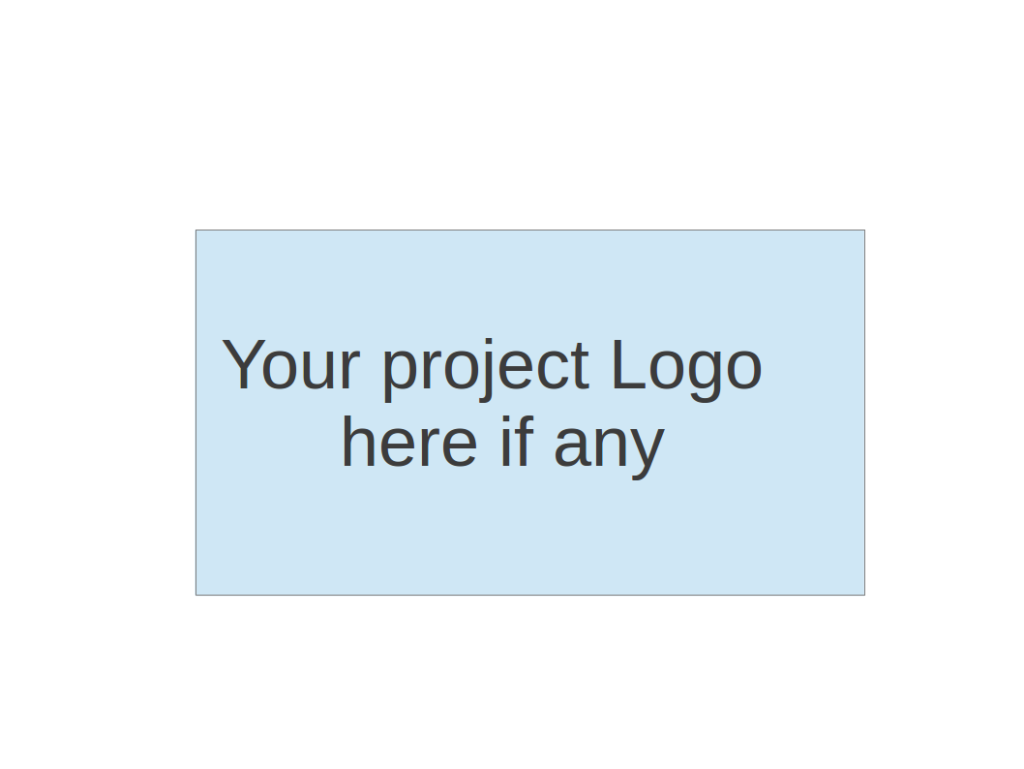
CS673 Software Engineering
Team 1 - AI Movie Recommendation Chat Bot
Project Proposal and Planning

Team Member | Role(s) | Signature | Date
Junshuo Huang | Team Leader | Junshuo Huang | 09/26/2026
Yung Cheng Chiu | Requirement Leader | Yung Cheng Chiu | 09/26/2026
Daniel Winnie | Design and Implementation Leader | Daniel Winnie | 09/26/2026
Yuchen Xu | Configuration Leader | Yuchen Xu | 09/26/2026
Jibek Kelgenbaeva | QA Leader | Jibek Kelgenbaeva | 09/26/2026
Ji Wu | Security Leader | Ji Wu | 09/26/2026

Revision history
Version | Author | Date | Change
0 | Everyone | 09/26/2026 | First draft

1. Overview
2. Related Work
3. Proposed High level Requirements
4. Management Plan
a. Objectives and Priorities
b. Risk Management (need to be updated constantly)
c. Timeline (this section should be filled in iteration 0 and updated at the end of each later iteration)
5. Configuration Management Plan
a. Tools
c. CI/CD Plan
6. Quality Assurance Plan
a. Metrics
c. Code Review Process
d. Testing
e. Defect Management
7. AI usage Log
8. Project Links
9. References
10. Glossary

(In your submitted document, please delete all instructions)

Overview
The goal of this project is to develop an AI Movie Recommendation Chat Bot that helps users find movies through natural language conversation. Users can describe their preferences, such as genre, mood, release year, or runtime, and the system will provide suitable movie recommendations with basic information.
The target users are people who want a faster and easier way to discover movies. The system will include a chat interface, movie recommendation, preference filtering, and movie information display. Possible technologies include HTML/CSS/JavaScript or React for the frontend, Python or Java in Jupyter Notebook for the backend, a movie database API, and an AI API for processing user requests.

Related Work
Netflix, IMDB, ChatGPT, Amazon. Our software is limited to being a chatbot that recommends movies to users.

Proposed High level Requirements
  - Functional Requirements
(For each functional requirement, please give a feature title and a brief description using the following format: As (a role), I want to (action), so that (value).)
    - Essential Features :(the core features that you definitely need to finish):
(For each essential features, please give a rough estimation in terms of person hours or a range of person hours)
- As a user, I want to use natural language to describe the movie I want to see, then I can receive the movie name list.
And I also want the chatbot show the recognize preference such as genre, release year and rating, so the recommendation can better match my interest

    - Desirable Features (the nice features that you really want to have too):
- As a user, I would like to see recommended movies and be able to view detailed information about them (such as synopsis, posters, main actors, director) to help me make informed choices.
- As a user, I would like to be able to ask follow-up questions or optimize recommendations (such as “Recommend similar movies” or “Show only movies available on Netflix”).
- As a user, I want to save recommended movies to my personal watchlist so that I can keep track of what to watch later.

    - Optional Features (additional cool features that you want to have if there is time):
- As a user, I want multi-language conversational support so that I can interact in my preferred language.
- As a user, I would like to see direct playback links or platform information for each recommended movie so I know where to watch it.

    - Existing Features (delete this item if your project starts from scratch)

  - Nonfunctional Requirements
(including security requirements, and other nonfunctional requirements such as compatibility, scalability, reliability etc)
    - Security requirements:
- API Key Protection: All third-party API keys must be strictly stored in server-side environment variables and never exposed to the client-side code.
- Input Sanitization: User inputs will be sanitized to guard against prompt injection and cross-site scripting (XSS) attacks.

    - Performance Requirements:
- Response Time: Recommendation responses generated by the chatbot should be rendered within 3 seconds under normal network conditions.
- Concurrency: The server backend must support multiple simultaneous user chat sessions without degradation in performance.

    - Usability & Compatibility Requirements:
- Cross-Platform Compatibility: The Web UI must be responsive and fully functional across major web browsers on both desktop and mobile devices.
- Usability:
- Rich Media Recommendation Cards: Recommendations must be presented using visual cards containing posters, ratings, genres, and brief synopses for quick scanning.
- Session Management: Users should be able to clear conversation history or start a new recommendation session with a single click.

Management Plan

Objectives and Priorities
Our project objectives, in descending order of priority, are:
- To create a chatbot that can recommend movies based on user natural-language questions.
- Create a website whose UI can let users access the chatbot easily.
- Add additional features to the website to push its functionality closer to a hybrid of ChatGPT and netflix such as watch parties, watch history, friends lists, as similar features.
And within those objectives we prioritize the following in no strict order:
- Maintain a clean github repository by utilizing branching and ensuring that large amounts of data which could be downloaded onto a user’s local device at setup, such as the IMDB information or LLM files, are not put directly on Github.
- Deploy the web app in a manner such that it can be easily presented or shared, so simply using a Jupyter notebook as the full project is not currently an acceptable objective.
- Have the web app be of high enough quality that’s both enjoyable to use and enjoyable to see as part of a presentation.
Allowing the website to be accessed remotely is not currently a priority, but may become one over time.

Risk Management (need to be updated constantly)
(Please write a summary paragraph about the main risks your group identified and how you plan to manage these risks. Then use the separate google sheet for detailed risk management. The template is provided in the same folder with this file. Please provide the link to the sheet.)
The main risks for our project are limited development time, integration issues between the chatbot and the website, and possible problems with external APIs or services. We may also encounter bugs when combining work from different team members. To manage these risks, we will divide the work clearly, test features as we divide them, and communicate regularly about our progress. If an external service is unavailable or too difficult to integrate, we will use a simpler local solution to make sure the main features can still be completed.

Risk Management Sheet Link:
https://docs.google.com/spreadsheets/d/1eszNAEokQFWaCUEWKCV6buAcKTdNjOg-7VpG3hyriro/edit?usp=drive_link

Timeline (this section should be filled in iteration 0 and updated at the end of each later iteration)
(The estimated hours should be realistic)
Iteration | Functional Requirements(Essential/Desirable/Optional) | Tasks (Cross requirements tasks) | Estimated/real total person hours
1 | Basic chatbot, Movie recommendation | Set up development environment, create basic UI, connect movie API, implement basic chatbot functions, | 25-35hours
2 | Movie information display, preference filter | Set up database, integrate frontend and backend, improve recommendation logic, and perform integration testing | 30-40hours
3 | Recommendation refine,  Recommendation history , Personal feedback | UI improvement, security review, system testing, bug fixing, deployment, and final documentation | 20-25hours

Configuration Management Plan

Tools
(In this project, we will use Git and Github as the version control tools. Please also specify any other tools to be used, e.g. IDE tools, CI/CD tools, container tools, SAST or DAST tools, and any other DevOps tools and AI tools

- IDE tools: Visual Studio Code
- CI/CD tools: Github
- SAST or DAST tools:
- DevOps tools & AI tools: GitHub Copilot, ChatGPT, Google Gemini

Visual Studio Code will be the main development environment. GitHub Actions may be used to automatically run basic tests whenever code is pushed or merged. GitHub CodeQL can be used to identify possible security problems in the source code. AI tools may be used to assist with coding, debugging, brainstorming, and documentation, but all AI-generated content and code will be reviewed by team members before being added to the project.

  - Code Commit Guideline and Git Branching Strategy
(Please briefly describe criteria for the code commitment and the branching strategy used, e.g. what are the branches to be used, how the pull request will be used etc. Here is an article to give you some basic knowledge about different git branching strategies: https://www.flagship.io/git-branching-strategies/

Code Commit Guideline:
Team members should commit code after completing a small and meaningful task, such as adding a new feature, fixing a bug, or updating documentation. Each commit should contain only related changes so that the project history remains clear and easy to track.
Commit messages should be short and clearly describe the change. For example:
- Add movie search feature
- Fix genre filtering bug
- Update chatbot interface
- Add API error handling
Before committing code, team members should make sure that the code runs correctly and does not break existing features. Large changes should be divided into smaller commits when possible.

Git Branching Strategy:
The project will use a simple feature branch strategy.
The main branch will contain the stable and working version of the project. Team members should avoid making major changes directly on the main branch.
When developing a new feature, a separate feature branch should be created. For example:
- feature/chat-interface
- feature/movie-search
- feature/ai-integration
If a bug needs to be fixed, a separate bug-fix branch can be created, such as:
- bugfix/year-filter
After the work on a branch is completed, the developer will create a Pull Request (PR) to merge the branch into main. At least one other team member should review the pull request before merging. The reviewer should check whether the code works correctly, follows the project coding standards, and does not create obvious problems with existing features.
The general workflow will be:
Main → Feature Branch → Development → Commit → Push → Pull Request → Code Review → Merge to Main

CI/CD Plan
(Briefly describe how you plan to continuously integrate and deploy your application).

CI Plan:
The project will use GitHub Actions for Continuous Integration. When team members push code or create a Pull Request, GitHub Actions will automatically run basic checks and tests.
The CI process may include:
- Running automated tests
- Checking whether the application builds successfully
- Checking for basic code errors
- Running security checks such as GitHub CodeQL
If a test or check fails, the problem should be fixed before the code is merged into the main branch. This process will help the team find problems early and reduce integration issues.

CD Plan:
During the early development stage, the application may be deployed manually while the main features are still being developed.
After the project becomes stable, the team may connect the main branch to a hosting platform so that the latest stable version can be deployed after successful testing.
The general process will be:
Feature Branch → Pull Request → Code Review → Automated Testing → Merge to Main → Deployment
Only code that passes review and testing should be deployed.

Quality Assurance Plan

Metrics
(Describe the metrics to be used in the project to measure the quality of your software. Each metric should be measurable and quantifiable. Examples of metrics include product complexity (LOC, # of files, # of classes, # methods, cyclomatic complexity, etc.) , defect rate (# of defect per KLOC), # of test cases, test case pass rate, cost (# of person hours used), # of user stories completed, etc. The result of these metrics should be reported in the progress report/ iteration summary sheet.)
Metric Name | Description
User stories completed | How much of the planned project is finished
Test case pass rate | How many tests are working
Defect rate | How many bugs there are
Recommendation relevance | How often chatbot meets user’s requests

  - Coding Standard
(Describe any coding standard to be used)
The project will follow consistent coding standards appropriate for the respective programming language including consistent naming conventions, indentation, line length, and documentation.
All code will have meaningful variable and function names, avoid unnecessary duplication, include comments when appropriate. Git commits will also be consistent and clearly describe changes made.
PEP 8 for Python, ESlint for JavaScript.

Code Review Process
(Everyone should review all documents to be submitted. Here you will mainly describe how the code review will be done. Who will review the code, e.g. design or implementation leader will review all code or team members review each other’s code. Do you use pull requests for the code review? Is there a checklist to help review? What feedback should the reviewer provide?)
Code will be reviewed by other team members before submission/merging. Pull requests will be used for code review. Reviewer will give thoughtful feedback.

Testing
(Both manual testing and automated testing should be considered. Both unit testing and integration testing should be considered. Briefly describe the testing tools/framework to be used, the personnel involved (e.g. the QA leader will focus on the integration testing and each developer will unit test their own code), when and what types of testing will be performed, the testing objectives, etc)
- Unit testing will be performed by individual developers on the components they implement. Unit tests will test individual backend functions, recommendation logic, data-processing functions, API endpoints, and other isolated components. Pytest will be used for Python backend testing.
- Integration testing will verify that major components work correctly together, including the frontend, backend API, database, recommendation system, and AI chatbot. API and integration tests will verify that user requests are correctly processed and that appropriate movie recommendations and chatbot responses are returned.
- Testing will be done consistently throughout development. Developers will perform unit testing during implementation and QA leader will focus on the integration testing.

Defect Management
(Describe the tool to be used to manage the defect (e.g github issues). The types of defects to look at. The actions or personnel for defect management. )
- GitHub Issues will be used to record and manage software defects. Each defeat will include a clear description of the problem, steps to reproduce it, expected behavior, actual behavior, severity, and the person responsible for addressing it when applicable.
- Team members who discover defects will create GitHub Issues and assign or notify the appropriate developer. The developer responsible will investigate, fix, and test the issue. Another team member will review the fix through a pull request before it is merged. The original issue will be closed once the fix has been verified.
- Defects will be reviewed during iteration meetings to prioritize unresolved issues and track the overall quality of the software.

AI usage Log
(This table summarizes AI contribution in this document)
Section | Who | AI contribution (%) | Description | Verified by
4c | Junshuo Huang | 35 | Ask Chatgpt for adding the main task in each iteration and estimate the time | Junshuo Huang
1(overview) | Junshuo Huang | 60 | Give the Ghatgpt our project idea and generate a overview | All group member

Project Links
Github link: https://github.com/BUMETCS673/CS673A1F26P1.git
Project management tool link (e.g. Jira):

References
(Any references/citations that you have used)

Glossary
(Any acronym used in the document should be explained here)
CI/CDContinuous Integration / Continuous Deployment
APIApplication Programming Interface

